HOW TO CONFIGURE DHCP RELAY AGENT ON CISCO LAYER 3 SWITCH

CONFIGURE DHCP RELAY AGENT | IP HELPER ADDRESS

Inacio Andre

2024

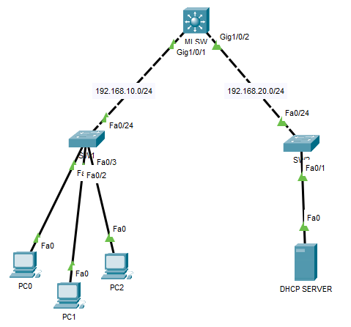

MLSW

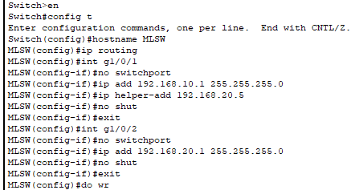

DHCP SERVER

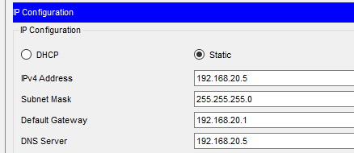

DHCP POOL

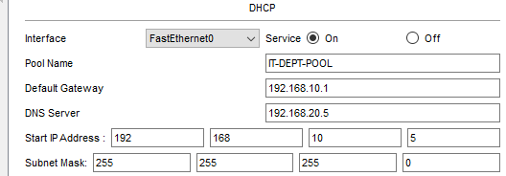

PC0

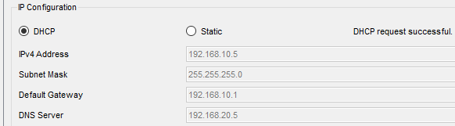

PC1

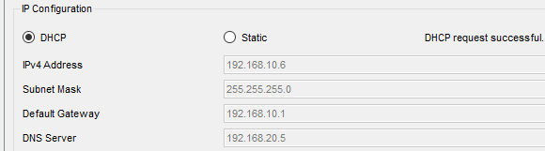

PC2

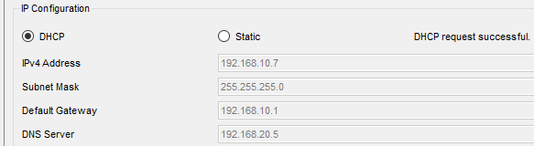

PC0-TO-PC1

